An Overview of Sabatons
Lately, I’ve been working on improving the look and authenticity of my armour. My armour is a late 14th century harness, broadly similar to the Churburg No. 13 armour (see fig. 1), or the horseman depicted on the altar piece in Pistoia Cathedral (see fig. 2).
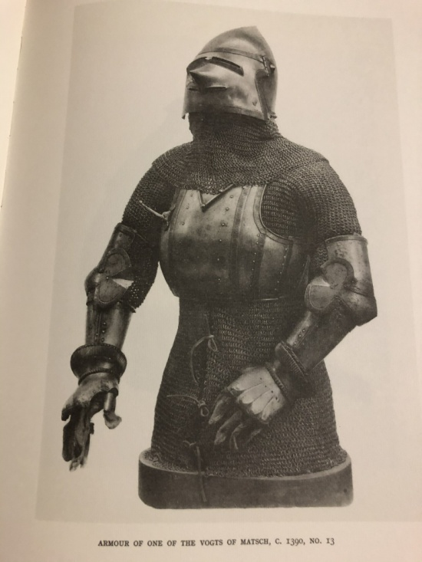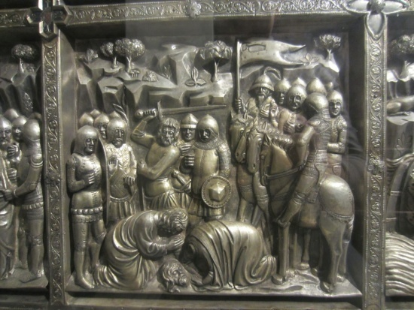
Fig. 1 Fig. 2
The next part of this cycle of improvements is to make a set of sabatons (armour for the feet). In SCA armoured combat we are not allowed to throw blows at or below our opponent’s knees. Since the lower legs and feet are not targets, sabatons are rare on an SCA battlefield; why carry the extra weight to protect something that is not allowed to be hit? In the late 14th century, however, sabatons were far more common than not in effigies, illuminations, brasses, and other visual records. So I wanted sabatons to help complete the correct look for my armour.
I do not have any patterns for sabatons. I decided that I’ll make my own patterns so I could get the look I wanted rather than just downloading something from the internet. But what look should I go for? I started looking through my collection of books on armour and quickly found out that I did not want what I thought I wanted. I had a look in mind for the sabatons, and I was looking to justify that look. When I went searching through the books I found that the sabatons I had been thinking of were mid to late 15th century, and would not be the correct look to go with a the rest of my armour. If authenticity is important to the project, the first thing you should pick up is a trustworthy reference!
How did sabatons develop over the centuries? In the 12th century and before an armoured warrior is typically wearing a shirt of mail or other armour that covers the body down to the knees, but leaves the lower leg and foot unarmoured. An excellent depiction of this is the Bayeux Tapestry (see fig. 3)
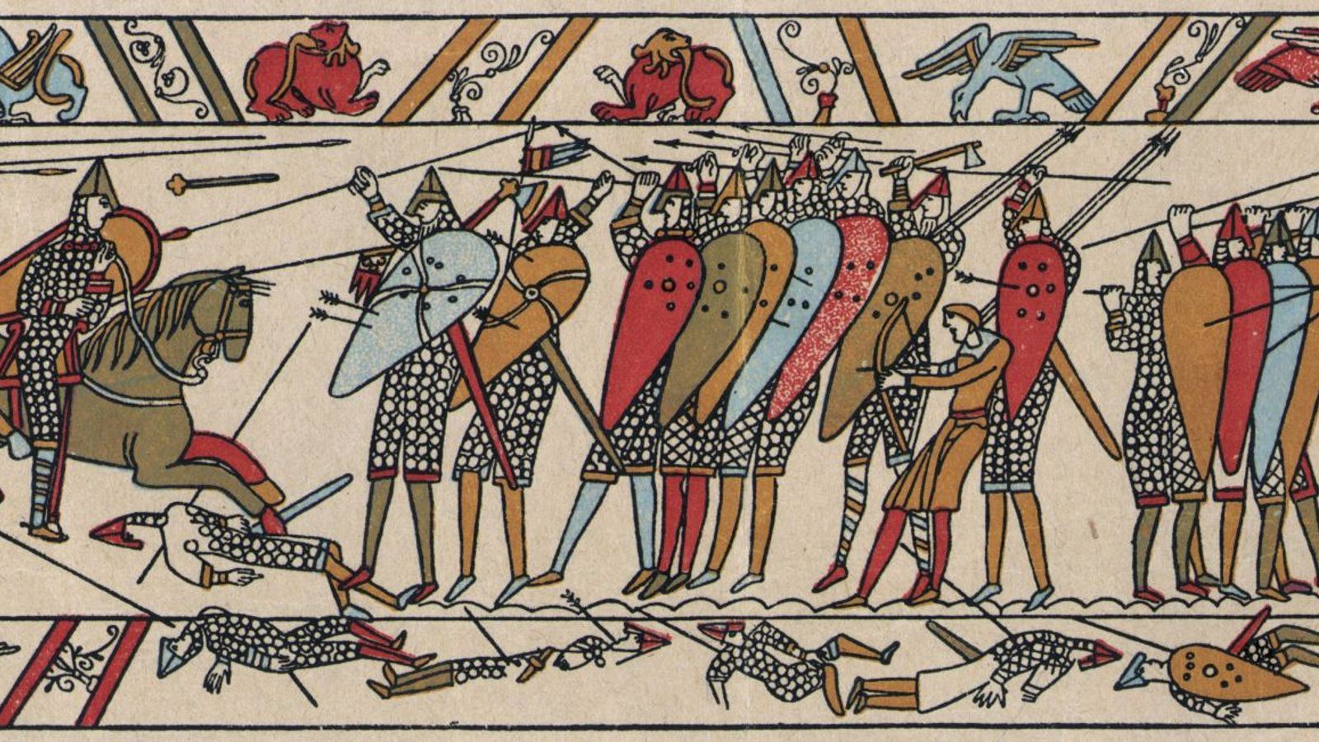
Fig. 3
We start seeing depictions of the feet being armoured in the 13th century. At this time the warriors are depicted as having their legs in mail. This sometimes looks like pants or trousers made of mail (see fig. 4). Other depictions show the back of the calf being open, then the mail being tied or laced together. Perhaps this was done to provide a more tailored fit to the mail and eliminate the extra motion of the flexible mail “slopping’ around the leg with every step (see fig. 5). In either case the armour for the foot is built into the leg armour in the same way feet are included in children’s pajamas today. Many of the depictions being from the front make it a matter of guesswork whether or not the mail is laced as in fig. 5 (see fig. 6)
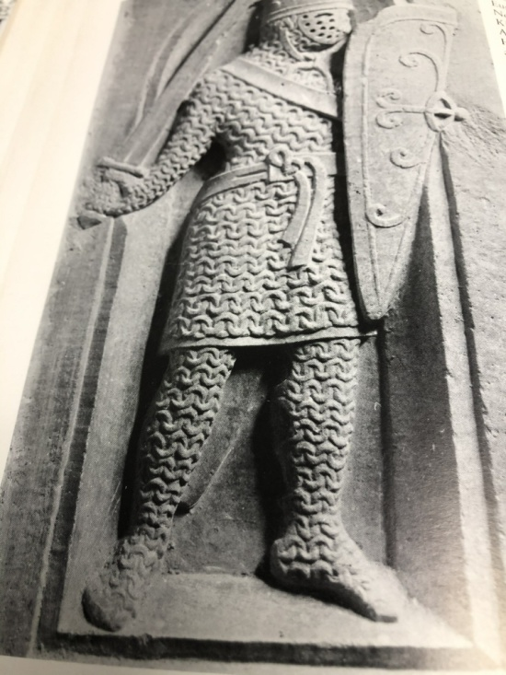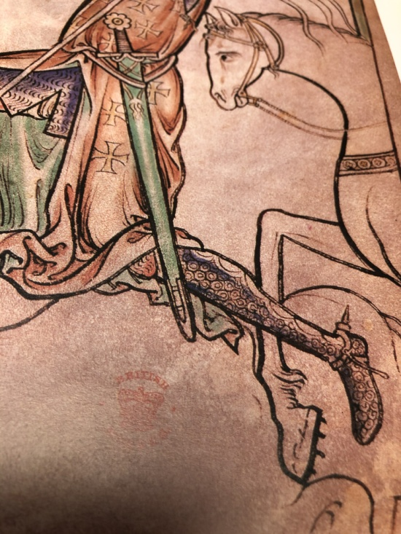
Fig. 4 fig. 5
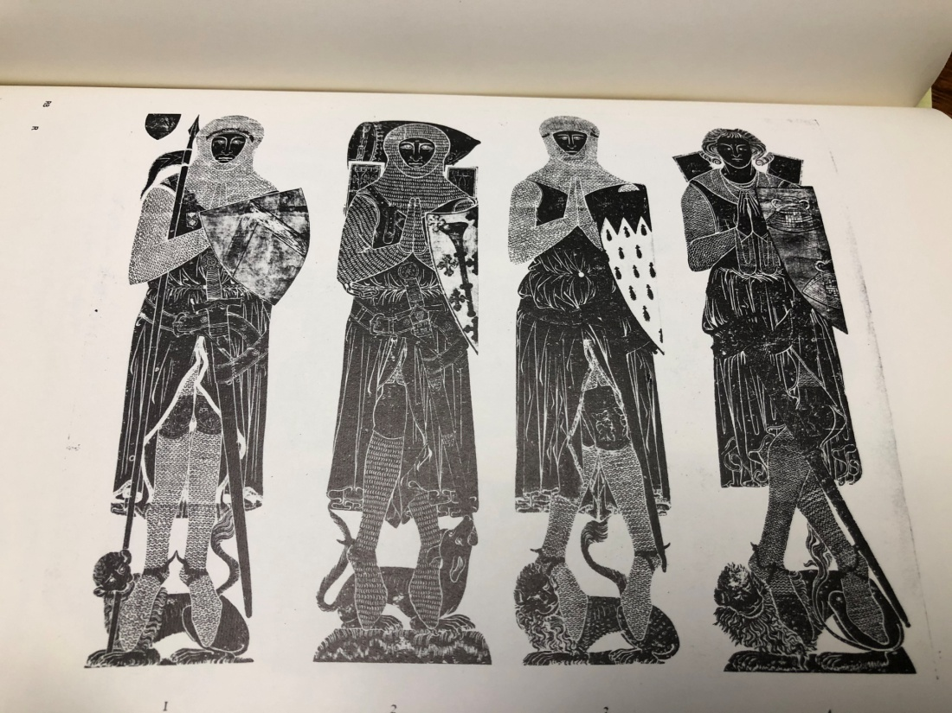
Fig.6
In the 14th century we start to see plate armour replacing mail as the predominate form of armour. We see plate over mail in the early part of the century (see fig. 7) transitioning to the foot being encased entirely in plate by the middle of the century (see fig. 8). These plate armour sabatons are of a small number of comparatively large plates underlapping each other towards the toes.
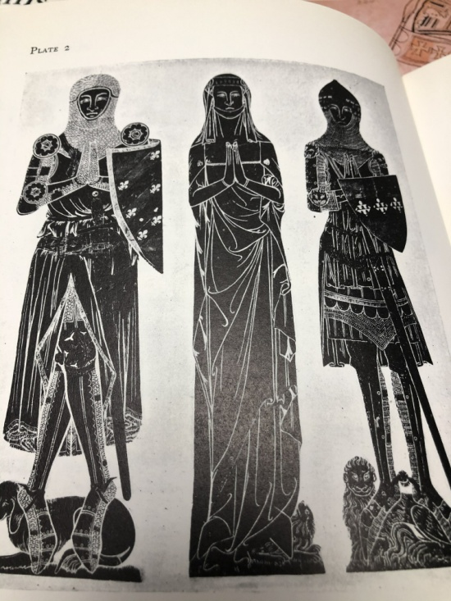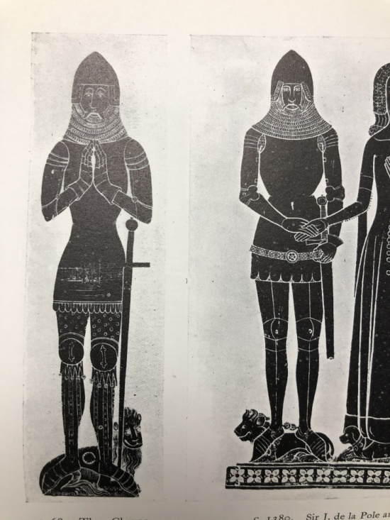
Fig. 7 Fig.8
In the 15th century we still see sabatons made in the older style of larger and fewer plates (see fig. 9). The sabaton in fig. 9 looks very similar to the sabatons in fig. 8 despite being dated to 1450 and thus solidly in the 15th century. We also start to see sabatons made of a larger number of articulating plates that are smaller in size and changing the direction of the underlap in the middle of the foot (see fig. 10). By the end of the century the sabatons are rarely a separate piece; they are mostly permanently attached to the greave. Interestingly, Churburg armour 20, dated from 1450 (the same as the sabaton in fig. 9) includes a rectangle of mail to cover each foot that is attached directly to the bottom of the greave (see fig. 11).

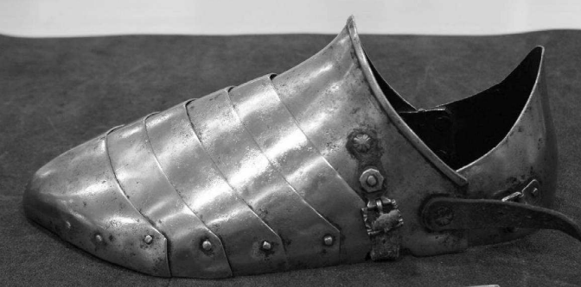
Fig. 9
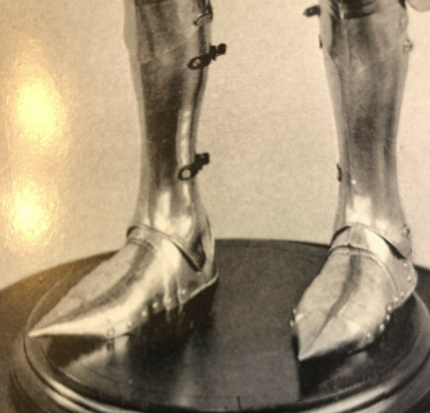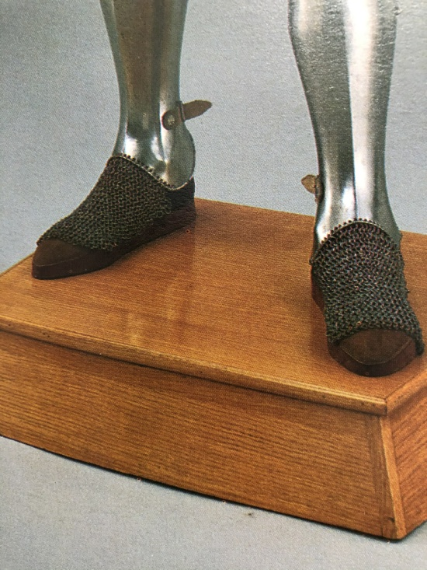
Fig. 10 Fig. 11
After the 15th century the changes to sabatons were mostly to follow the fashion trends of civilian foot gear until sabatons were discarded in the general move away from armour on the battlefield (see fig.12). An exception to sabatons being made of articulating plates is an armour from the royal workshops at Greenwich from 1550. The armour includes sabatons made mostly of mail similar to the Churburg armour above. However, in this armour the mail is not directly connected to the greave, and includes a plate cap to cover the toes that is punched to be mounted on the mail (see fig. 13).
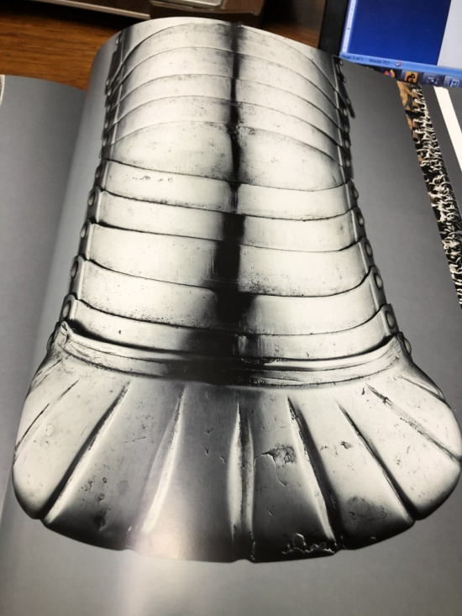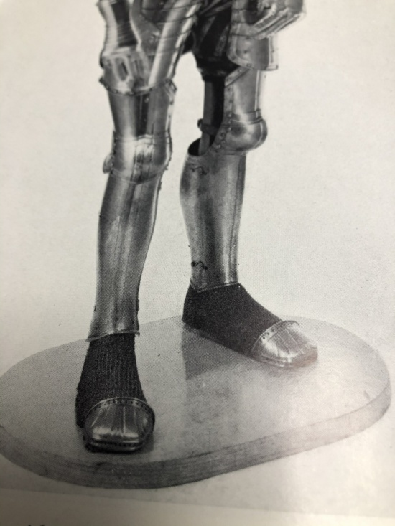
Fig. 12 Fig. 13
So, we now have a broad outline of the development of sabatons. To fit with the correct look for my armour, I will be making a set similar to what is shown in fig. 9. This keeps to the time frame of the armour and keeps to the correct look for the armour as a whole. There are some other areas to consider to help with the goal of getting the correct look for the sabatons.
How should the sabatons be articulated? While the example shown in fig. 9 articulates on clearly visible rivets, most of the effigies and brasses do not show these rivets. Without visible rivets they would have to articulate on interior leather strips. In “Armour of the English Knight 1400 - 1450” Tobias Capwell makes this argument in explaining the choices he made in how his armour was constructed. I am concerned with the durability of the internal leathers. My (pre-covid) time in armour averaged about two fighting practices and a tournament per week. I’ve had to replace too many broken straps from places on my armour that don’t see as much stretching and bending as my feet have to go through. I will go with the visible articulating rivets for the increased durability as compared to internal leathers.
As a separate point about the articulation, it can be easy to overlook that sabatons should articulate up, not down. In other words the sabaton allows the wearer to raise their toes, but not to curl their toes. When you step forward you flex the foot so that you are making contact with the ground with your whole foot, then only the ball of your foot, then you pick the foot off the ground. The sabaton must flex up to allow this motion. When you want to flex the foot down, the motion is mostly happening in your ankle, not in any significant bending of the foot itself. The sabaton must not hinder the motion of the ankle, but it doesn’t have to flex down to any great degree.
Should the edges of the plates be rolled or folded for extra strength? This was common on the sabatons of the 15th century (you can see the edge rolling in fig. 16 if you look closely), but seems to be rare in the 14th century. I’ll leave the edges plain.
How should the sabatons be held closed? The choices come down to strap and buckle, spring pin (push the pin in, hard, to release the plate), or catch pin (a hook goes through the pin and must be moved to release the plate). For durability and ease of emergency day of repair I’ll go with a strap and buckle. Both push pins and catch pins are generally a bit later than my armour and are harder to repair in the middle of a Pennsic woods battle.
Which sides to the hinges and buckles go on? Knightly armour was built with the expectation that at some point the wearer of the armour would be spending time on a horse. The smoothest side should go to the inside, where it is less likely to interfere with directing the horse. For these sabatons that means the hinges go on the inside edge of the sabatons, and the buckle goes on the outside edge. To further smooth the horse side of the sabatons I will set the hinges inside the sabatons (between the wearer’s foot and the steel of the sabaton) rather than mounting the hinges on the outside surface of the steel.
How do you keep the sabaton from flopping around on your foot? In the 14th century sabatons, there are generally no holes in the toe section of the sabatons to tie them to the shoe underneath, the method common in later sabatons. I will be running straps under the sabaton (see fig. 14 and fig. 15). This will take some experimentation to find leather that is thick enough to hold up to the stress, but not so thick it becomes a distraction under my foot. There is only a single strap roughly under the ball of the foot in both fig. 14 and fig. 15. Exact placement of the strap will be another thing for me to experiment with.
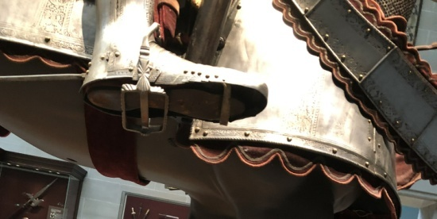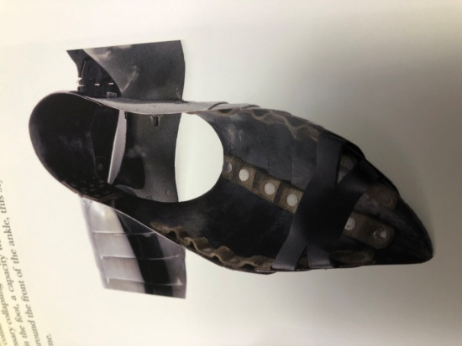
Fig. 14 Fig. 15
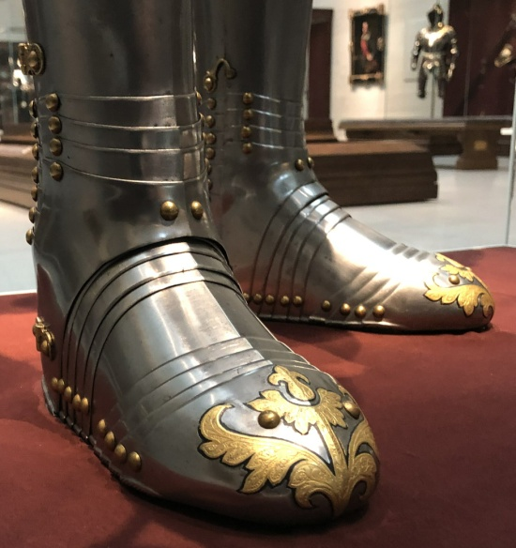
Fig. 16

Sources of pictures used:
Fig 1 –“The Armoury of the Castle Churburg” by Oswald Graf Trapp. Translated by James Gow Mann. armour c1390
Fig 2 - Altar piece in Pistoia Cathedral in Italy c1376, image found online
Fig 3 - The Bayeux Tapestry image, found online
Fig 4 –“Arms and Armor of the Medieval Knight” by David Edge & John Miles Paddock. Relief in church of St. Justina, Padua of a Knight c1210, page 52
Fig 5 –“Arms and Armor of the Medieval Knight” by David Edge & John Miles Paddock. page 51. A miniature from the Westminster Psalter by Matthew Paris c1250
Fig 6 –“Victoria and Albert Museum Catalogue of Rubbings of Brasses ands Incised Slabs” by Muriel
Clayton, plate 1
Fig 7 - -“ Victoria and Albert Museum Catalogue of Rubbings of Brasses ands Incised Slabs’ by Muriel
Clayton, plate 2
Fig 8 –‘Victoria and Albert Museum Catalogue of Rubbings of Brasses ands Incised Slabs” by Muriel
Clayton, plate 6
Fig 9 –“Armourers and Their Workshops” PhD Thesis by Nickolas Dupras, page 440
Fig. 10 – “The John WoodmAN Higgins Armory Catalog of Armor” by Stephen Grancsay, page 33
Fig.11 –“Arms and Armor of the Medieval Knight” by David Edge & John Miles Paddock, page 111
Fig. 12 –“Masterpieces of Medieval and Renaissance Arms and Armour From the National Collection vol. 1” by Hans Prunner, page 271
Fig. 13 –‘European Armour in the Tower of London” by Richard Dufty, plate XL
Fig. 14 - Armour for man and horse displayed at Cleveland Museum of Art
Fig. 15 –“Armour of the English Knight 1400 – 1450” by Tobias Capwell, page 274
Fig. 16 – Armour of Archduke Charles II of Austria. On loan from the Kunsthistorisches Museum in Vienna to the Cleveland Museum of Art

